MED D - Excluded Drugs

General Rules for Excluded Drugs
Extra Help
Financial Assistance
Drug Detail Screen - Medicare D Approved Drug Indicator
Related Documents

Description: This document covers the list of excluded Part D drugs and how to locate the Medicare D drug indicator in the drug detail screen in PeopleSafe.

General Rules for Excluded Drugs
These are the three general rules about drugs that Medicare drug plans will not cover under Part D:
- A drug that would be covered under Medicare Part A or Part B.
- A drug purchased outside the United States and its territories.
- “Off-label use” of a drug. “Off-label use” of a drug is any use of the drug other than those indicated on a drug’s label as approved by the Food and Drug Administration.
Example: Diabetic drugs being used for weight loss (Ozempic, Rybelsus, Wegovy, Mounjaro, Saxenda, Semaglutide)
    - Note: Any beneficiaries that are new to diabetic medications commonly used for weight-loss will be required to get a Prior Authorization.
- Generally, coverage for “off-label use” is allowed only when the use is supported by certain reference books. These reference books are the American Hospital Formulary Service Drug Information, the DRUGDEX Information System, National Comprehensive Cancer Network (NCCN), Clinical Pharmacology, or its successor. If the use is not supported by any of these reference materials, then our plan cannot cover its “off-label use.”

Also, the following drugs are excluded from the Medicare prescription drug benefit:
- Non-prescription drugs (also called over-the-counter drugs).
- Drugs used to promote fertility.
- Drugs used for symptomatic relief of cough and colds.
- Drugs when used for cosmetic purposes or to promote hair growth.
- Prescription vitamins and minerals, except prenatal vitamins and fluoride preparations.
- Drugs when used for the treatment of sexual or erectile dysfunction, such as Viagra/Sildenafil, Cialis/Tadalafil, and Caverject.
- Drugs used for weight loss, weight gain, or anorexia.
  - Example: Diabetic drugs being used for weight loss (Ozempic, Rybelsus, Wegovy, Mounjaro, Saxenda, Semaglutide)
    - Note: Any beneficiaries that are new to diabetic medications commonly used for weight-loss will be required to get a Prior Authorization.
- Outpatient drugs for which the manufacturer seeks to require that associated tests or monitoring services be purchased exclusively from the manufacturer as a condition of sale.
- Prescription drugs obtained outside of the US and its territories, even in an emergency.

Top of the Document

Extra Help
Your state Medicaid program may cover some prescription drugs not normally covered in a Medicare Drug Plan. Contact your state Medicaid program to determine what drug coverage may be available.

Your medication was denied on the Medicare portion of your plan; however, this does not mean that the medication is not covered. The medication may be covered by your Enhanced Wrap Benefit. You can check your commercial formulary to determine if it is covered.

Top of the Document

Financial Assistance
If the beneficiary states they are unable to afford the Med D excluded medication refer to Prescription Financial Assistance for Members.

Top of the Document

Drug Detail Screen - Medicare D Approved Drug Indicator

To locate the drug detail screen follow these steps:
Step | Action
1 | Scroll down to the desired claim.
2 | On the Main screen, click on the Prescription Number hyperlink.  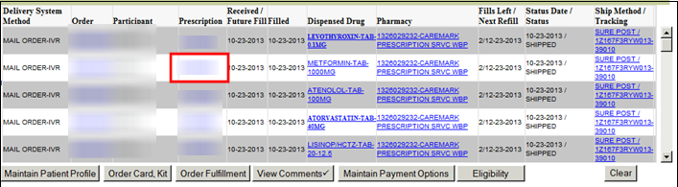  Result: Prescription Detail screen.
3 | On the Prescription Detail screen, scroll down to the Drug section and click on the Dispensed ID.  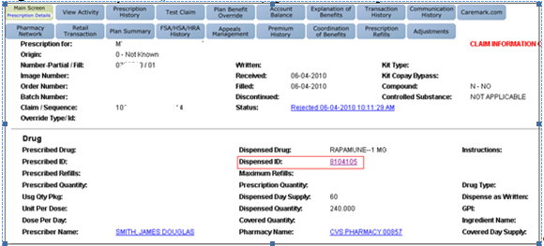  Result: Drug Detail Screen.
4 | On the Drug Detail screen, under the Indicators section, find the field titled MedD:  - Y = Medicare D Approved Drug  - N = Medicare D Non-Approved (Excluded) Drug.  Note: Select the comments button to view comments for the selected drug.  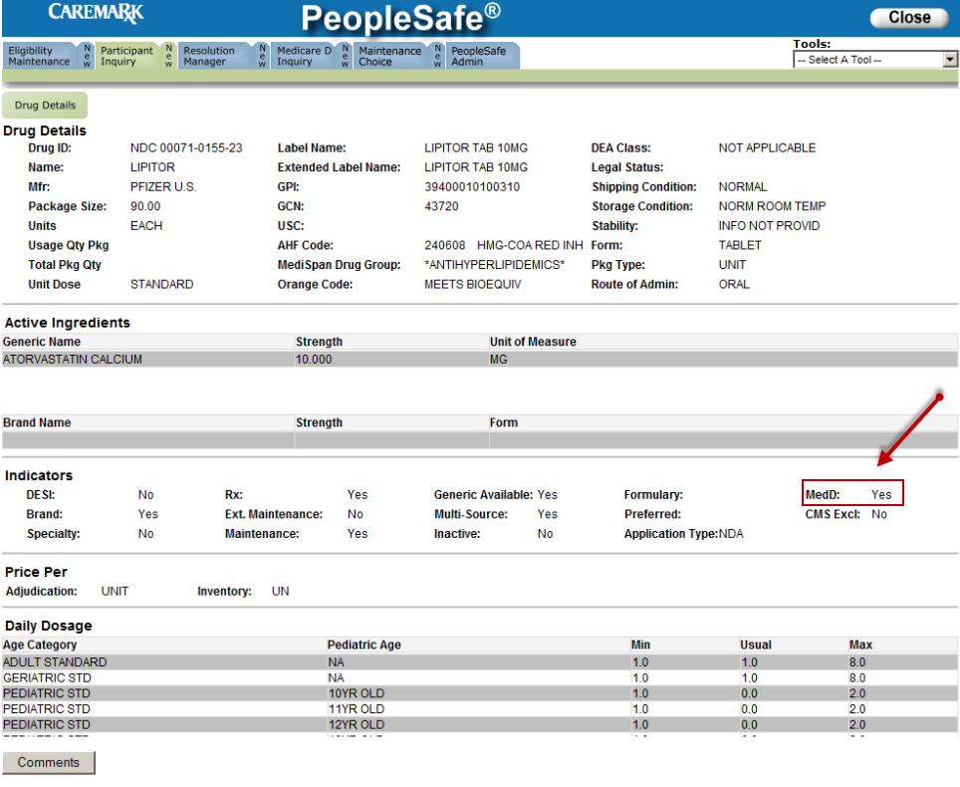

Top of the Document

Related Documents
Grievance Standard Verbiage (for use in Discussion with Beneficiary) section in MED D - Grievances Index

Parent SOP: CALL-0048: Medicare Part D Customer Care Call Center Requirements-CVS Caremark Part D Services, L.L.C.
Abbreviations/Definitions: Abbreviations / Definitions

Top of the Document

Not To Be Reproduced Or Disclosed to Others Without Prior Written Approval
ELECTRONIC DATA = OFFICIAL VERSION – PAPER COPY = INFORMATIONAL ONLY

